University of Central Punjab
Faculty of Information Technology
Object Oriented Programming
Spring 2025
Lab 05
NAME: M. HUSSIAN DURRANI
ROLL NO: L1F24BSCS0937
SECTION: C-9

Task 1: Rectangle Class
OUTPUT:
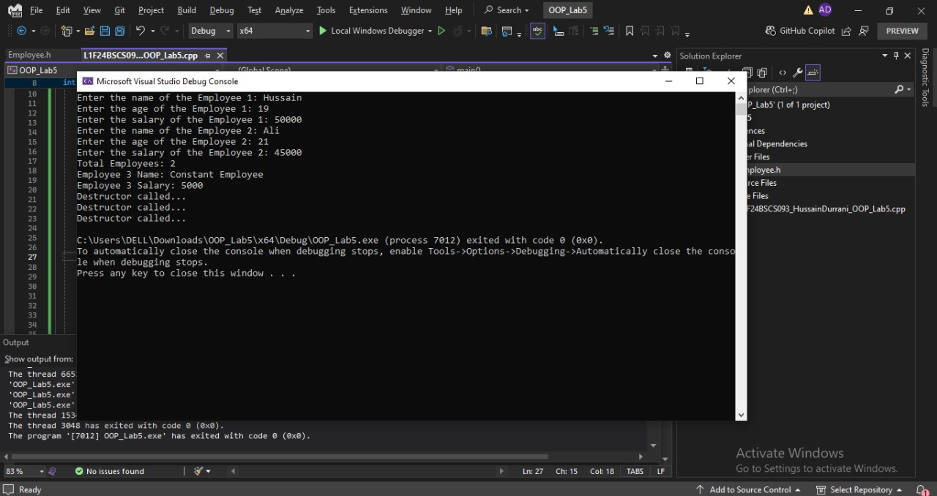

Task 2: Product Class
OUTPUT:
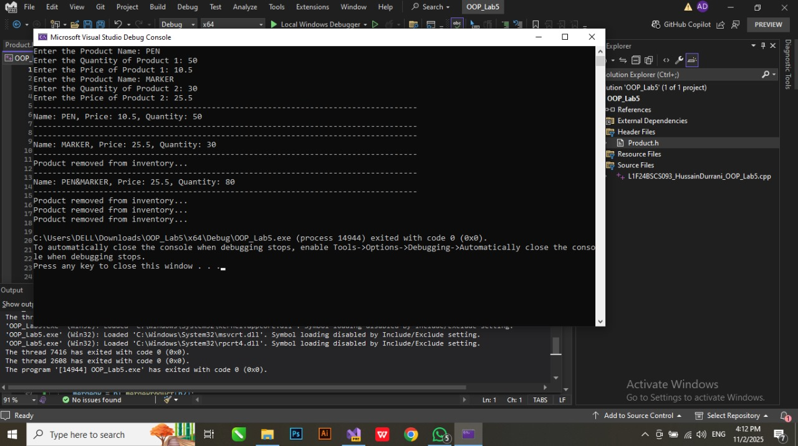

Task 3: Student Class
OUTPUT:
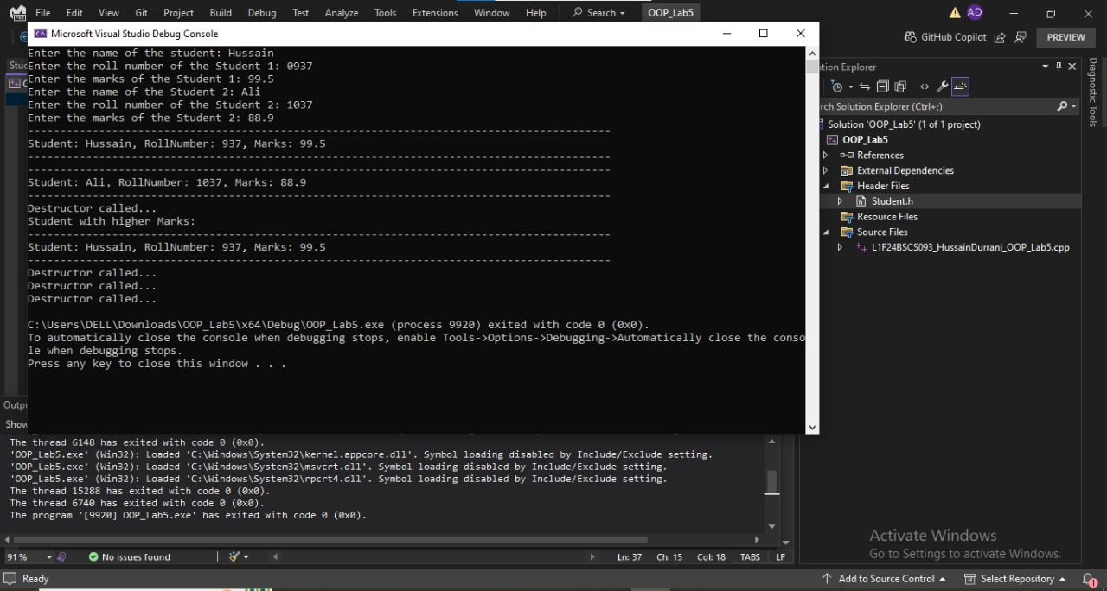

Task4: Employee Class
OUTPUT:
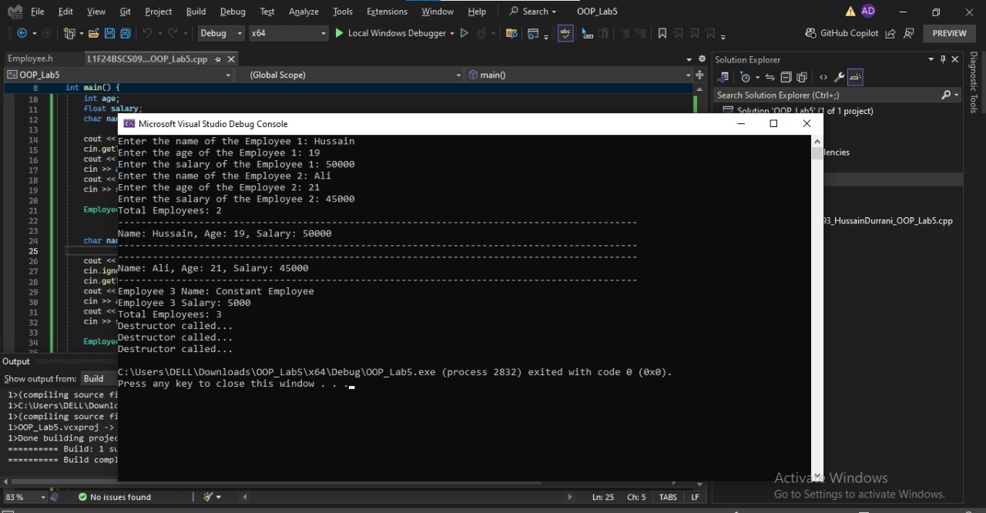

Task5: Student Class

OUTPUT:
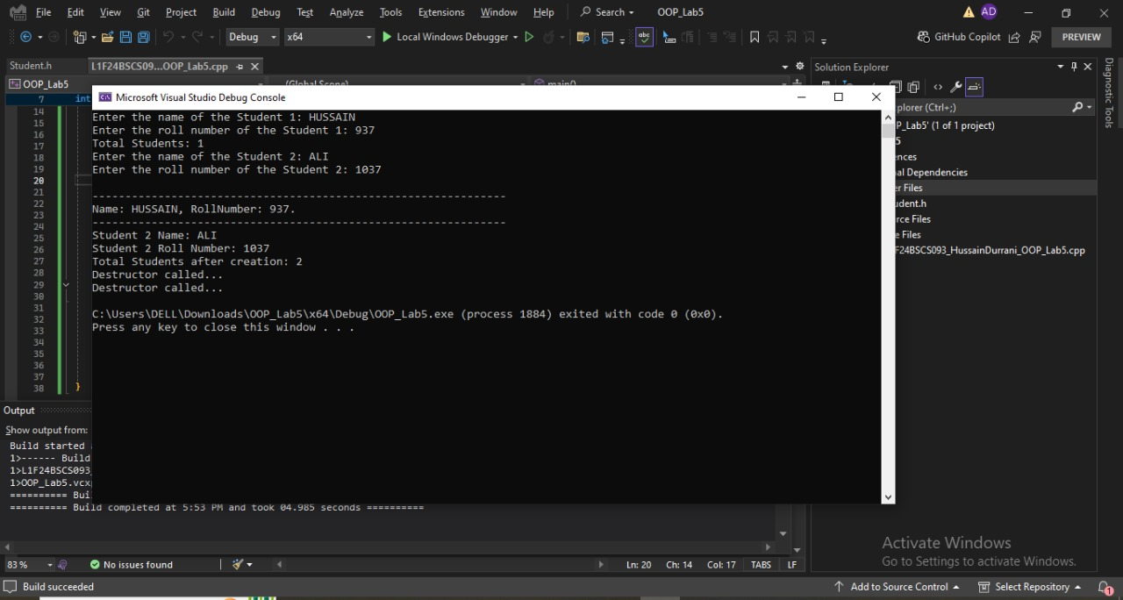

Task 6: BankAccount Class
OUTPUT:
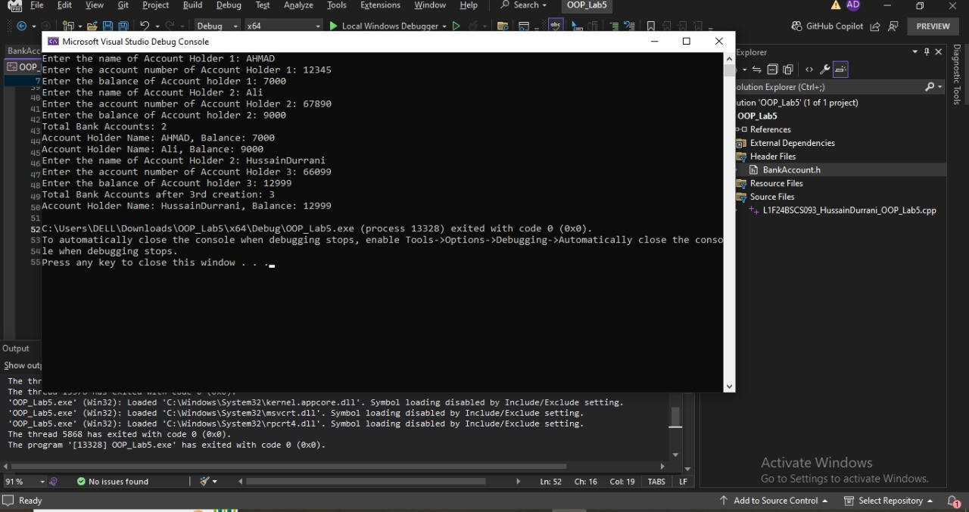

Task 7: Counter Class
OUTPUT:
